Website amendments

Home page – My logo is too small and can’t be seen with the colours. It also doesn’t need to move down the page. If it is bigger and a better colour it can stay where it is please.

I don’t like the video of the couple getting married as the celebrant is obviously not me. I will provide more photos to add if needed – is this AI generated movement?
Photo’s need to be aligned so they can be seen properly – my head is cut off in the photo with the married couple. I would like the photo of the Asian couple changed – I have provided some more photos to use – the photo is too dark and I would prefer a brighter photo please.

I’d like to change all the headings to red please - as it is on the helpful llnks page.

I love the My Services area of the page – however when you click the links they need to go to correct section please, as at the moment they don’t.

Why choose me – the photo resolution isn’t great. I will send the original and see if you can increase the resolution when it is zoomed in please. When you click on ‘Get to know Helen’ box it takes you to the bottom of Meet Helen page – this needs to go to the top of the page please.

When you click on ‘Contact Me’ box it takes you to the bottom of the ‘Let’s Talk’ page – this needs to link to the top of the page please. On this page - Photo of me is covered – needs to be visible and the photo of the couple cutting the cake can’t be seen either. There is a random box to the right of this photo, can this be removed please.

Meet Helen – You can’t see me at the top in the photo – if you need another photo please let me know. I will send some so you can see what you think. Again when you click on ‘Contact Me’ box – it takes you to the bottom of the linked page rather than the top. The rest of that page I really like…thank you.

FAQ – I would prefer a slightly different font so that the Q looks like a Q rather than a 2 please. You also can’t see & Answers with the background. I do really like the Sunflowers though – more appropriate than you would know…thank you. Again when you click on ‘Contact Me’ box – it takes you to the bottom of the linked page rather than the top. The rest of that page I really like…thank you. Really like the rest of that page…thank you.

Helpful links – the photo of the lady, I think I would rather that was a photo of something like this please

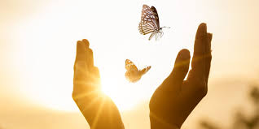

Again when you click on ‘Contact Me’ box – it takes you to the bottom of the linked page rather than the top. I really like the rest of that page…thank you.

Costs – Please can the figure just be there rather than the number scrolling. Also the background photo of the funerals I would prefer that is was the crematorium rather than the lady please, if it needs to be a lighter picture to allow for the writing contrast then would something like this be ok please

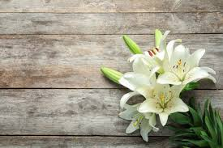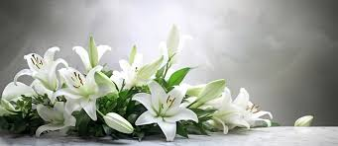

The font has the J (Just honest, heartfelt service.) looking like an F – what do you think, should it be different please?
Again when you click on ‘Contact Me’ box – it takes you to the bottom of the linked page rather than the top. I really like the rest of that page…thank you.

Wedding and vow renewal – Again not the right video as the celebrant is obviously not me. Please use any of the photos I have sent to you that you feel is appropriate – I am happy for these to be generated to be moving images.

Vow renewal photo I don’t like that photo – sorry. I do like this one from my home page – would it be possible to use that one instead please?
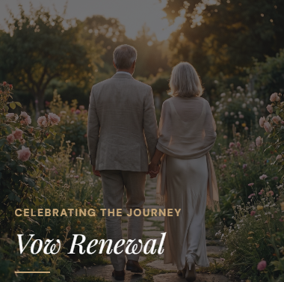

Again when you click on ‘Contact Me’ box – it takes you to the bottom of the linked page rather than the top. I really like the rest of that page…thank you.

Funeral & Memorials – The photo that goes with Memorial Services I would like this to be more like this please, if they can be adjusted to be portrait?

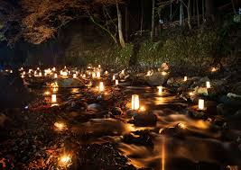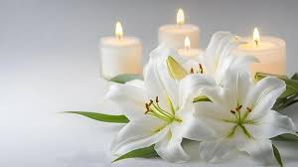

The font shows the Q’s looking like a 2 – I think this needs to be changed across the whole website please. Again when you click on ‘Contact Me’ box – it takes you to the bottom of the linked page rather than the top. I really like the rest of that page…thank you. I really like the rest of the page…

Why choose me – the photo is zoomed in too far, I would prefer that it wasn’t so close up please. Again clicking on get to know Helen – it goes to the bottom of the page – I would like it to go to the top – same as all the other links please.

When some of the links for the pages are clicked it doesn’t go to the top of the page and I would like them to please.

Let’s Talk – you can’t see me!! I have mentioned the photos on this page above. Can we remove the full stop on the heading please.

The red I think is lighter than the sample I sent so would prefer it to be slightly darker please.

I have made a mock up of my logo with colours as I visualised it. I think your design is better, just needs to be bigger on the website and visible please.

I have re-read my ‘Why Choose Me’ words – would you please change them slightly to read…’I will bring a calm, caring approach to your ceremony, while taking the time to understand’ and ‘important moments in their lives, which I have always done with compassion, patience, and understanding’. Hopefully that makes sense!

